Australian Native Hardwood species: Gidgee

- Gidgee Acacia Cambagei

Photos of Gidgee timbers show the rich colour and very tight grain.

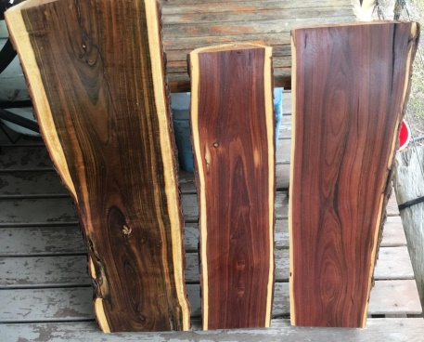  Two left hand timbers Gidgee, right hand timber Lance wood. | 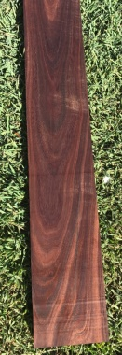  Gidgee as flooring blank. | 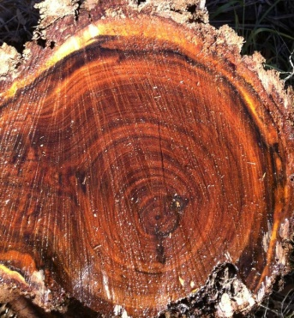  Gidgee sawn log end grain

Details:
- Gidgee logs are small.
- Spec - minimum top end Diameter 16 cm .
- Length 1.8 m and longer .
- 20% of logs will show some pipe.
- Big volume available.
- Species suits Parquetry because short lengths and Diameters.
- Chinese use Lancewood which also small Diameter.

- Gidgee wood (Acacia Cambagei) is commonly known as "Stinking Wattle". It is also one of the hardest timbers in the world. Gidgee wood has a reputation as one of the most beautiful timbers turned or carved. It has very distinct colours, fine grain and extreme hardness.
- It grows in the arid outback of Queensland and Northern Territory. Some trees grow up to 600mm in diameter and over 10m tall. It is a dense timber, weighing 1300kg per cubic metre.
- Gidgee is classified as the 3rd hardest wood in the world, according to The Wood Data Base. Janka hardness test measures the hardness of wood and rates this timer at 19.
(Janka Hardness Test)
- The timber is primarily used for fence posts because of it's durability. They can last over 100 years in the ground. Much of the timber is not straight and can only be used for firewood or making charcoal.
- Machining the timber is difficult but the end result is very rewarding. Timber floors (that are almost scratch resistant), furniture, musical instruments and hand crafted pieces. When polished, the grain is extraordinary with excellent colour contrasts.

- Common Name(s): Gidgee
- Scientific Name: Acacia cambagei, A. pruinocarpa
- Distribution: Endemic to Australia
- Tree Size: 20-40 ft (6-12 m) tall, 1 ft (.3 m) trunk diameter
- Average Dried Weight: 72 lbs/ft³ (1,150 kg/m³)
- Specific Gravity (Basic, 12% MC): .93, 1.15
- Janka Hardness: 4,270 lb_{f} (18,990 N)
- Modulus of Rupture: 18,850 lb_{f}/in² (130.0 MPa)*
- Elastic Modulus: 2,683,000 lb_{f}/in² (18.50 GPa)*
- Crushing Strength: 10,150 lb_{f}/in² (70.0 MPa)*
- *Conservative values based on strength group/bracket
- Shrinkage: Radial: 4.0%, Tangential: 5.1%, Volumetric: 9.2%, T/R Ratio: 1.3
- Color/Appearance: Heartwood is medium to dark reddish brown, sometimes with darker streaks. Sharply demarcated sapwood is yellow. Curly figuring is also seen on some pieces, and is called “ringed gidgee.”
For more information contact
David Bliss
Marketing manager
True Timbers a division of
True Fruits Australia Pty Ltd.
Email: David@terfels.com.au

